Project 4

**Program Description**

In this program, I implemented a login and registration page. I used SQLite DB for this project.

The purpose of this application is to play a song for you depending on your mood. There are 10 moods to choose from and each one gives you a different song. I was working on this project by myself, but if there were more people in my team then I would be able to add more songs to each mood and each time you click the mood, it would play a random song from the list.

**Login**

If you do not want to register to the app, you can directly login with a premade login. The email is [admin@gmail.com](mailto:admin@gmail.com) and password is “password”.

***Activity 1 screenshot –*** *This is the registration page. When you first open the app, it takes you to the registration page. If you already have an account and do not wish to register for a new account, then you are free to login to your existing account.*

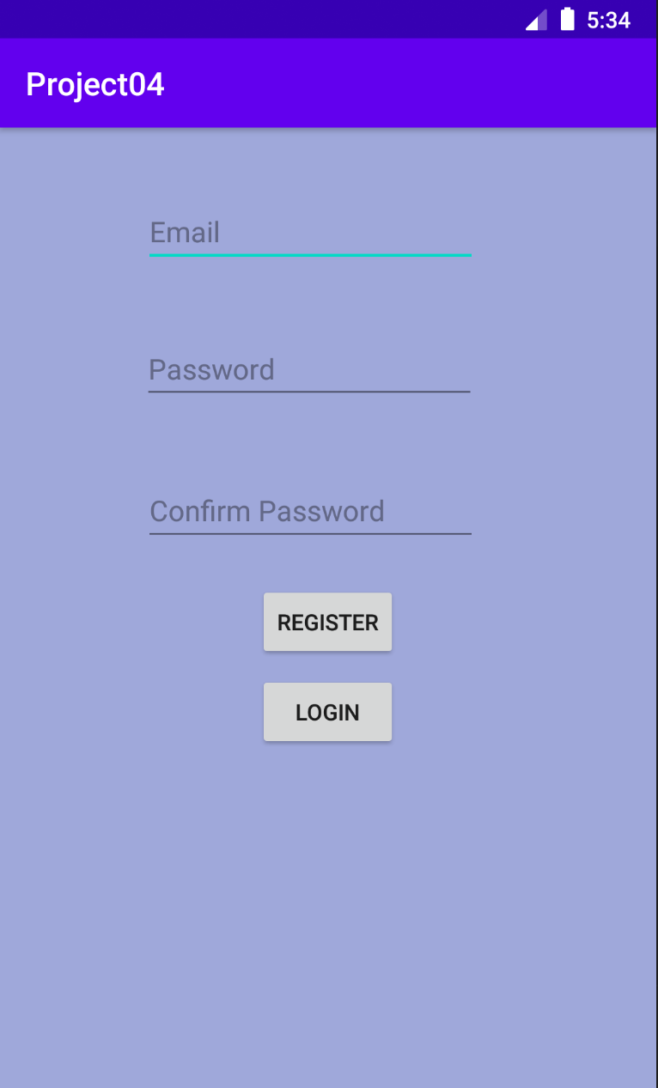

***Activity 2 screenshot –*** *This is the login page that allows you to login if you already have an account.*

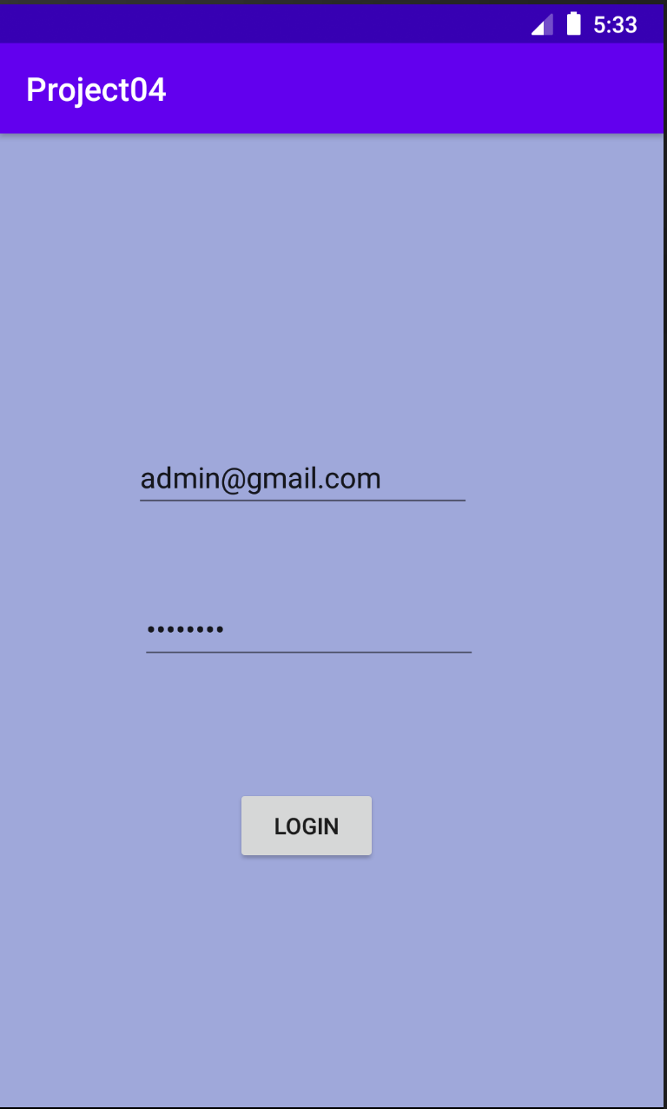

***Activity 3 screenshot –*** *This the page that opens up once you are logged in to the app. It gives you a display of different moods that you can choose to listen to your music. If you are happy, you can choose the happy mood and it will play a song according to that mood.*

